BUSINESS REPORT

ADVANCED STATISTICS

Anmol Gambhir
G4 PGDSBA.O.May 23.A
Contents

Problem 1 (Probability : Physiotherapist – Football Team)
1.1. ………………………………………………………………………………………………….. …………………3
1.2. …………………………………………………………………………………………………………………………………………………….……. 3
1.3. …………………………………………………………………….......................................................................................... 3
1.4. …………………………………………………………………………………………………………………………………………………….….....4
1.5. …………………………………………………………………………………………………………………………………………………………….4:

Problem 2 (Probability : Nuclear Power Plant)
2.1 …………………………………………………………………………….…………………………………...…..5
2.2 …………………………………………………………………………………..…………………………..……..5
2.3 ……………………………………………………………………………………..………………..……………....5
Problem 3 (Breaking Strength of gunny bags of packaging cement)
3.1 ……………………………………………………………………………………………………………………….6
3.2 ……………………………….…………………………………………………………………………… ………7
3.3 ………………………………………………..………………………………………………..……………………8
3.4 …………..……………………………………………………………………………………………………..….…9
Problem 4 (Grades of Final Exam of Training Course)
4.1 ……………………………………………………………………………………………………………………...10
4.2 ……………………………….………………………………………………………………………… ……… 10
4.3 ………………………………………………..………………………………………………..…………..………10

Problem 5 (Zingaro Company)
5.1 ……………………………………………………………………………………………………………………...11
5.2 ……………………………….………………………………………………………………………… ……… 12

Problem 6 (Aquarious Health Club) ……………………………………..………………..13 & 14

Problem 7 (Dental Implant Data)
7.1 ……………………………………………………………………………………………………………………...15
7.2 ……………………………….………………………………………………………………………… ……… 17
7.3 ……………………………………………………………………………………………………………………...19
7.4 ……………………………….………………………………………………………………………… ……… 21
7.5 ………………………………………………..………………………………………………..…………..………23
7.6 ……………………………………………………………………………………………………………………...24
7.7 ……………………………….………………………………………………………………………… ……… 25

Problem 1

A physiotherapist with a male football team is interested in studying the relationship between foot injuries and the positions at which the players play from the data collected

 | Striker | Forward | Attacking Midfielder | Winger | Total
Players Injured | 45 | 56 | 24 | 20 | 145
Players Not Injured | 32 | 38 | 11 | 9 | 90
Total | 77 | 94 | 35 | 29 | 235

  - Probability that a randomly chosen player would suffer an injury:

Ans: From the table:

Players injured (a) = 145
Total players (b) = 235
Probability that a randomly chosen player would suffer
an injury is a/b i.e 145/235=0.6170 or 61.70%

  - Probability that a player is a forward or a winger:

Ans: From the table:

Total Forwards (a) = 94
Total Wingers (b) = 29
Total players (c) = 235
Probability that a player is a forward or a winger is (a+b)/c i.e (94+29)/235=0.5234 or 52.34%

  - Probability that a randomly chosen player plays in a striker position and has a foot injury:

Ans: From the table:

No of injured strikers (a) = 45
Total No of players (b) =235
Probability that a randomly chosen player plays in a striker position and
has a foot injury is a/b i.e 45/235=0.1915 or 19.15%

  - Probability that a randomly chosen injured player is a striker:

Ans: From the table:

No of injured strikers (a) = 45
Total of injured players (b) = 145
Probability that a randomly chosen player plays in a striker position and
has a foot injury is a/b i.e 45/145=0.3103 or 31.03%

  - Probability that a randomly chosen injured player is either a forward or an attacking midfielder:

Ans: From the table:

Total injured Forwards (a) = 56
Total injured attacking midfielder (b) = 24
Total No of injured players (c) = 145
Probability that a player is a forward or a winger is (a+b)/c i.e (56+24)/145=0.5517 or 55.17%

Problem 2
An independent research organization is trying to estimate the probability that an accident at a nuclear power plant will result in radiation leakage. The types of accidents possible at the plant are, fire hazards, mechanical failure, or human error. The research organization also knows that two or more types of accidents cannot occur simultaneously.
According to the studies carried out by the organization, the probability of a radiation leak in case of a fire is 20%, the probability of a radiation leak in case of a mechanical 50%, and the probability of a radiation leak in case of a human error is 10%. The studies also showed the following;
- The probability of a radiation leak occurring simultaneously with a fire is 0.1%.
- The probability of a radiation leak occurring simultaneously with a mechanical failure is 0.15%.
- The probability of a radiation leak occurring simultaneously with a human error is 0.12%.
2.1 Probabilities of a fire, a mechanical failure, and a human error respectively?
Let,
P(A)= Probability of radiation leak
P(B)= Probability of fire
P(C)= Probability of mechanical failure
P(D)= Probability of human error
Given,
P(A/B)=0.2
P(A/C)=0.5
P(A/D)=0.1
P(AՈB)=0.001
(AՈC)=0.0015
P(AՈD)=0.0012
2.1.1 Ans: Probability of Fire P(B)=P(AՈB)/P(A/B) i.e. 0.001/0.2 = 0.005 i.e. 0.5%
2.1.1 Ans: Probability of mechanical failure P(C)=P(AՈC)/P(A/C) i.e. 0.0015/0.5 = 0.003 i.e. 0.3%
2.1.1 Ans: Probability of human error P(D)=P(AՈD)/P(A/D) i.e. 0.0012/0.1 = 0.012 i.e. 1.2%

2.2 Probability of a radiation leak:
Ans:
P(A) = 1- {P(B)+P(C)+P(D)} = 1- (0.005+0.003+0.012) = 0.98 i.e. 98%

  - Suppose there has been a radiation leak in the reactor for which the definite cause is not known.

    - In case of a radiation leak probability of being caused by fire:

Ans:

P(B/A)=P(AՈB)/P(A) i.e. 0.001/0.98 = 0.00102 i.e. 0.102%

2.3.2 In case of a radiation leak probability of being caused by mechanical failure:

Ans:
P(C/A)= P(AՈC)/P(A) i.e. 0.0015/0.98 = 0.00153 i.e. 0.153%

2.3.3 In case of a radiation leak probability of being caused by human error:

Ans:
P(D/A)= P(AՈD)/P(A) i.e. 0.0012/0.98 = 0.00122 i.e. 0.122%

Problem 3:
The breaking strength of gunny bags used for packaging cement is normally distributed with a mean of 5 kg per sq. centimeter and a standard deviation of 1.5 kg per sq. centimeter. The quality team of the cement company wants to know the following about the packaging material to better understand wastage or pilferage within the supply chain; Answer the questions below based on the given information; (Provide an appropriate visual representation of your answers)
3.1 Proportion of the gunny bags have a breaking strength less than 3.17 kg per sq cm:
Ans:
Calculating the z statistic: z = (3.17-5)/1.5 = - 1.22
From Python, Area to the left of normal distribution curve is stats.norm.cdf (-1.22) = 0.1122
Therefore, the proportion of the gunny bags have a breaking strength less than 3.17 kg per sq cm
shall be 11.22%.
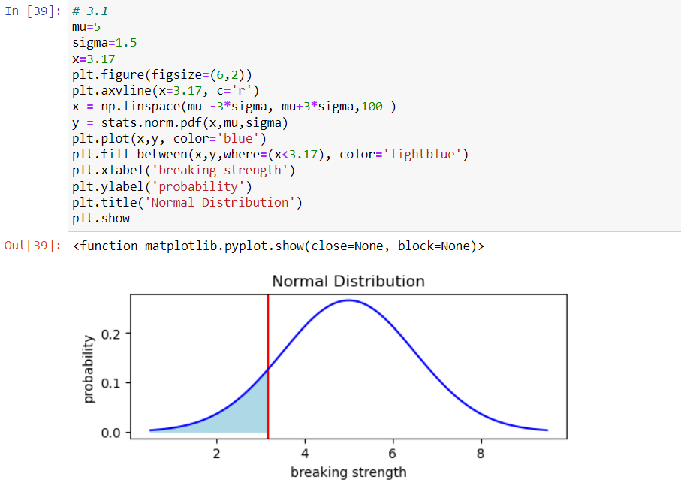

3.2 Proportion of the gunny bags have a breaking strength at least 3.6 kg per sq cm.
Ans:
Calculating the z statistic: z = (3.6-5)/1.5 = - 0.93
From Python, Area to the right of normal distribution curve is 1-stats.norm.cdf (-0.93) = 0.8238
Therefore, the proportion of the gunny bags have a breaking strength at least than 3.6 kg per sq cm shall be 82.38%.
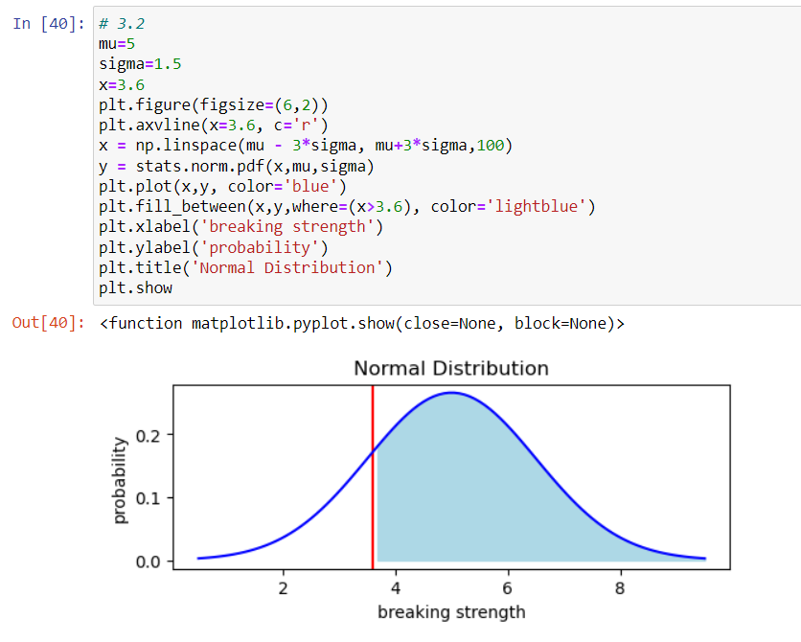

3.3 Proportion of the gunny bags having a breaking strength between 5 and 5.5 kg per sq cm.
Ans:
Calculating the z statistic:
z1 = (5-5)/1.5 , z1 = 0
z2= (5.5-5)/1.5, z2 = 0.93
From Python, area between z2 and z1 of normal distribution curve is :
norm.cdf(0.33) - norm.cdf(0.00) = 0.1293
Therefore, proportion of the gunny bags having a breaking strength between 5 and 5.5 kg per sq cm shall be 12.93%.

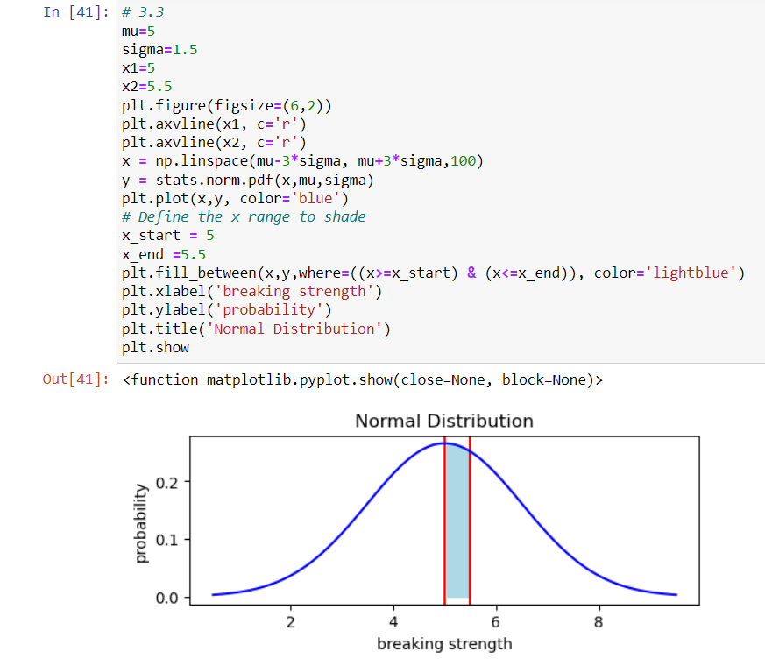

3.4 Proportion of the gunny bags have a breaking strength NOT between 3 and 7.5 kg per sq cm.
Ans:
Calculating the z statistic:
z1=(3-5)/1.5 = - 1.33
z2=(7.5-5)/1.5 = 1.67
From Python, area NOT between z2 and z1 of normal distribution curve is
1-(norm.cdf(1.67) - norm.cdf(-1.33)) = 0.1392
Therefore, proportion of the gunny bags have a breaking strength NOT between 3 and 7.5 kg per sq cm shall be 13.92%.
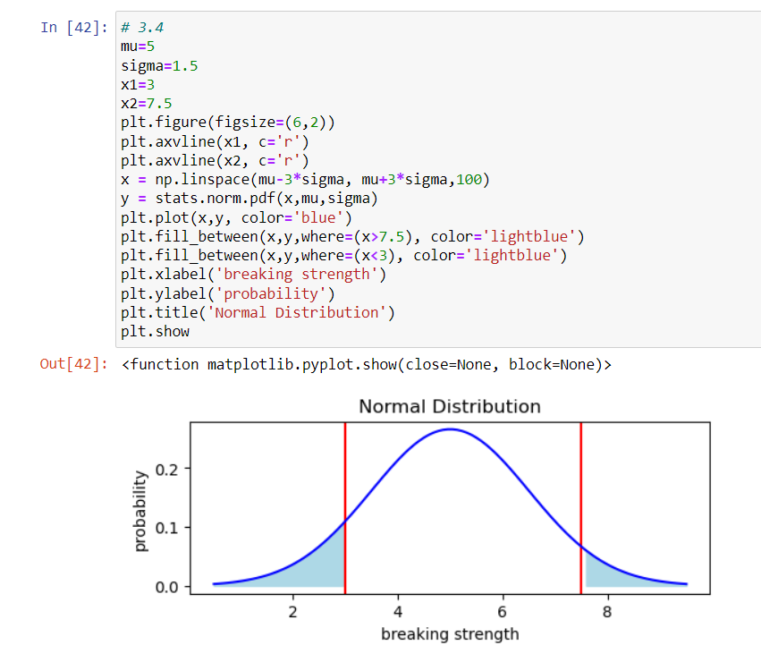

Problem 4:

Grades of the final examination in a training course are found to be normally distributed, with a mean of 77 and a standard deviation of 8.5. Based on the given information answer the questions below:

4.1 Probability that a randomly chosen student gets a grade below 85 on this exam:
Ans:
Calculating the z statistic : z = (85-77)/8.5 = 0.94
From Python, Computing the probability: stats.norm.cdf (0.94) = 0.8264
Therefore, there is 82.64% probability that a randomly chosen student gets a grade below 85 in this exam.

4.2 Probability that a randomly selected student scores between 65 and 87:
Ans:
Calculating the z statistic:
z1 = (65-77)/8.5
z2= (87-77)/8.5
From Python, Computing the probability: stats.norm.cdf (z2) - stats.norm.cdf (z1) = 0.8013
Therefore, there is 80.13% probability that a randomly selected student scores between 65 and 87.

4.3 Passing cut-off so that 75% of the students clear the exam:
Ans:
mu = 77
sigma = 8.5
From Python, passing_cut_off = norm.ppf (0.75, mu , sigma)
print('passing cut off should be', round (passing_cut_off))
Output: Passing cut off should be 83
Therefore, passing cut-off so that 75% of the students clear the exam is 83.

Problem 5:

Zingaro stone printing is a company that specializes in printing images or patterns on polished or unpolished stones. However, for the optimum level of printing of the image the stone surface has to have a Brinell's hardness index of at least 150. Recently, Zingaro has received a batch of polished and unpolished stones from its clients. Use the data provided to answer the following (assuming a 5% significance level);
5.1 Earlier experience of Zingaro with this particular client is favorable as the stone surface was found to be of adequate hardness. However, Zingaro has reason to believe now that the unpolished stones may not be suitable for printing. Do you think Zingaro is justified in thinking so?
Ans: The data of Zingaro Company was read in Jupyter Notebook and the description is as under:
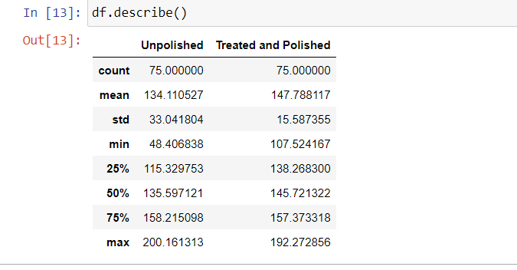
- First, creating a 95% Confidence Interval for Unpolished Stones:

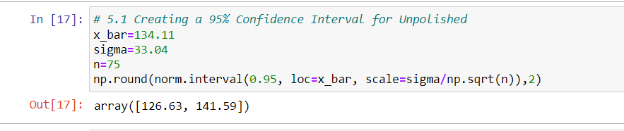

- Thereafter, creating a 95% Confidence Interval for Treated and Polished Stones:
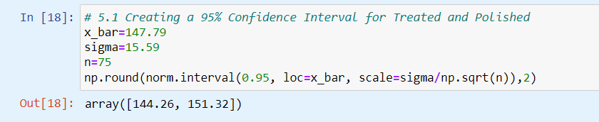
From the 95% Confidence Interval of Unpolished Stones, it is seen that Brinell Hardness Index of Unpolished Stones is between 126.63 and 141.59, which is less than 150 required for optimum level of printing. Whereas , Brinell Hardness Index of Treated and Polished Stones is between 144.26 and 151.32, which is close to 150 required for optimum level of printing.
Hence, we can conclude with 95% confidence that Zingaro Company is justified in thinking that Unpolished Stones may not be suitable for printing.

5.2 Is the mean hardness of the polished and unpolished stones the same:
Ans: 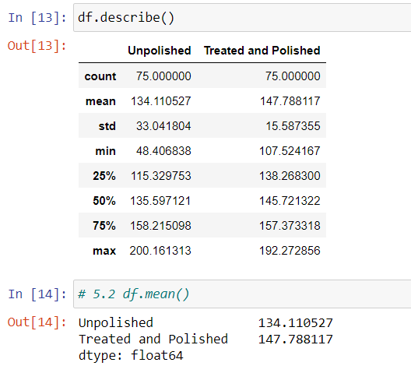
From the description and mean of the data, it can be observed that Mean of Unpolished Stones is 134.11 and Mean of Treated and Polished Stones is 147.79.

Therefore, means of hardness of Unpolished and Polished Stones are not the same.

Problem 6:

Aquarius health club, one of the largest and most popular cross-fit gyms in the country has been advertising a rigorous program for body conditioning. The program is considered successful if the candidate is able to do more than 5 push-ups, as compared to when he/she enrolled in the program. Using the sample data provided can you conclude whether the program is successful? (Consider the level of Significance as 5%)
Note that this is a problem of the paired-t-test. Since the claim is that the training will make a difference of more than 5, the null and alternative hypotheses must be formed accordingly.
Ans:

The data of Aquarius Health Club was read and Python study for the Paired T Test was done. The observations and result is as under:

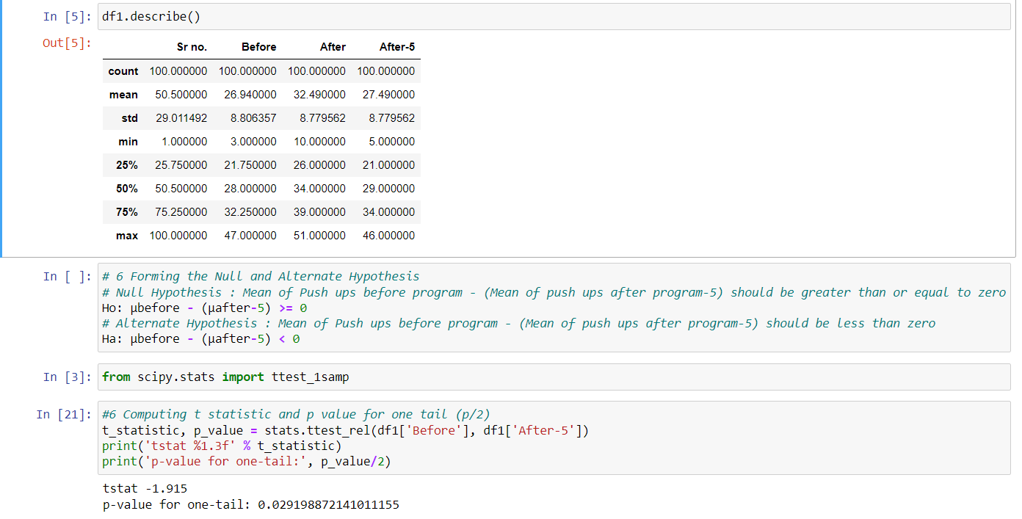

Since, the program is considered successful when the candidate is able to do more than 5 push ups , as compared to when he/she enrolled in the program. Therefore one more column is created in the data, after-5. Accordingly, Null and Alternate Hypotheses are formed as under:

Null Hypothesis: Mean of Push ups before program – (Mean of push ups after program-5) should be greater than or equal to zero

Ho: µbefore – (µafter-5) >= 0

Alternate Hypothesis: Mean of Push ups before program – (Mean of push ups after program-5) should be less than zero

Ha: µbefore – (µafter-5) < 0

T Statistic and p value for one tail in a paired t test (p/2) were computed using Python and the values are as under:

T Statistic is 1.915

P value for one tail is 0.029

Since, p value is less than α (0.05), we shall reject the Null Hypothesis

i.e. µbefore – (µafter-5) < 0

Therefore, we can conclude that the program has not been able to increase the number of push ups by more than 5. Hence, the program is not successful at 95% significance.

Problem 7:

Dental implant data: The hardness of metal implant in dental cavities depends on multiple factors, such as the method of implant, the temperature at which the metal is treated, the alloy used as well as on the dentists who may favour one method above another and may work better in his/her favourite method. The response is the variable of interest.
  - Test whether there is any difference among the dentists on the implant hardness. State the null and alternative hypotheses. Note that both types of alloys cannot be considered together. You must state the null and alternative hypotheses separately for the two types of alloys.

Ans:

The Dental Hardness Data was read and the Python study such as type of variables, outliers and normality of data was done. It was found that Dentist, Method and Allloy are Integer variables. These were changed to Categorical Variables.

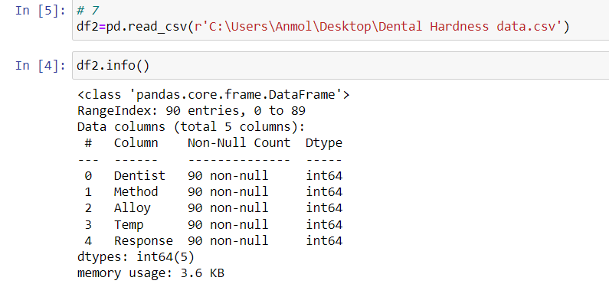
Null and Alternate Hypotheses are formed as under:

For Alloy A:

Null Hypothesis: Mean of Response (Hardness of Dental Implant) for all Five Dentists are equal

Ho: µ1A= µ2A =µ3A= µ4A =µ5A

Alternate Hypothesis: Mean of Response (Hardness of Dental Implant) for all Five Dentists are not equal

Ho: µ1A ǂ µ2A ǂµ3Aǂ µ4A ǂµ5A

For Alloy B:

Null Hypothesis: Mean of Response (Hardness of Dental Implant) for all Five Dentist are equal

Ho: µ1B= B=µ3B= µ4B =µ5B

Alternate Hypothesis: Mean of Response (Hardness of Dental Implant) for all Five Dentist are not equal

Ho: µ1B ǂ µ2B ǂµ3Bǂ µ4B ǂµ5B

N way ANOVA study was done using Python and value of F Statistic and p value were found.

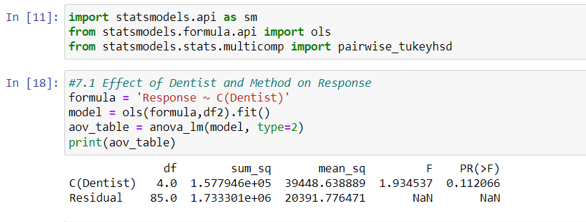
It was observed from the above ANOVA table that p value 0.11 is greater than α (0.05), we Accept the Null Hypothesis at 95% significance. It is concluded that there is no significance effect of Dentist on Implant Hardness. The same is also plotted for both types of alloys and the same is as under:

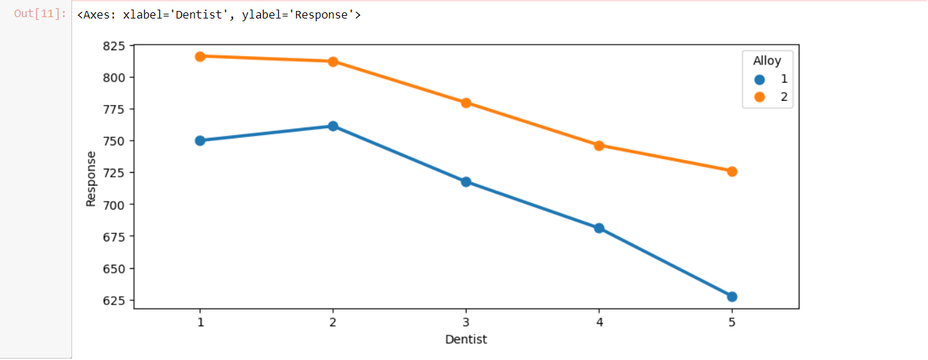
  - Before the hypotheses may be tested, state the required assumptions. Are the assumptions fulfilled? Comment separately on both alloy types.

Ans: The assumptions of n way ANOVA for the problem and their fulfillment is as under:

Sl. No. | Assumption for n Way ANOVA | Is the Assumption fulfilled | Separately for both Alloys
1. | Dependent Variables should be measured at continuous level | Fulfilled: The Dependent Variable i.e. Response (Hardness of Implant) is measured at continuous level | Yes
2. | Independent Variables should each consist of two or more categorical independent groups | Fulfilled: There are three independent categorical variables i.e. Dentist, Method and Alloy and one Integer Variable i.e. Temperature | Yes
3. | There should be no significant outliers | Not Fulfilled: It was observed that Dependent Variable i.e. Response has significant outliers (checked from Python study) | Yes
4. | Dependent Variables should be Normally Distributed for each combination of groups of independent variables | Fulfilled: Dependent Variable i.e. Response (Implant Hardness) is Normally distributed (checked from Python study) | Yes

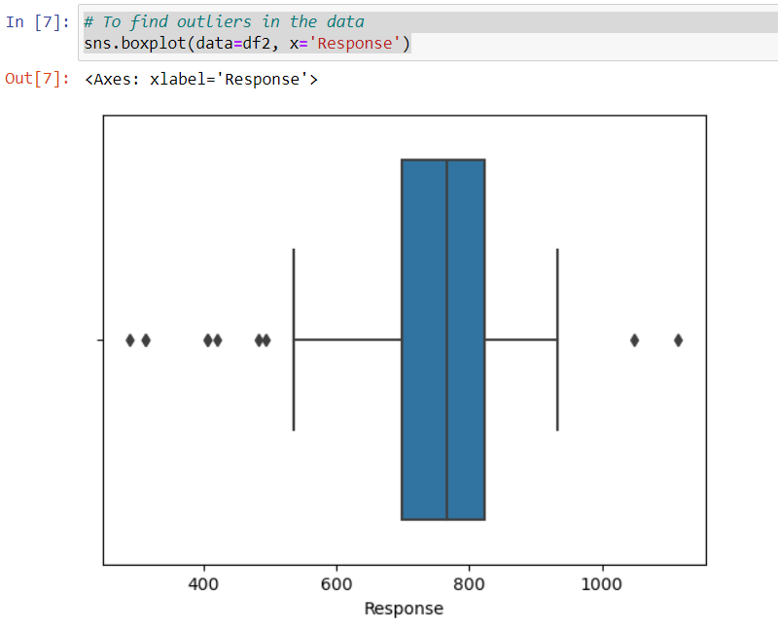

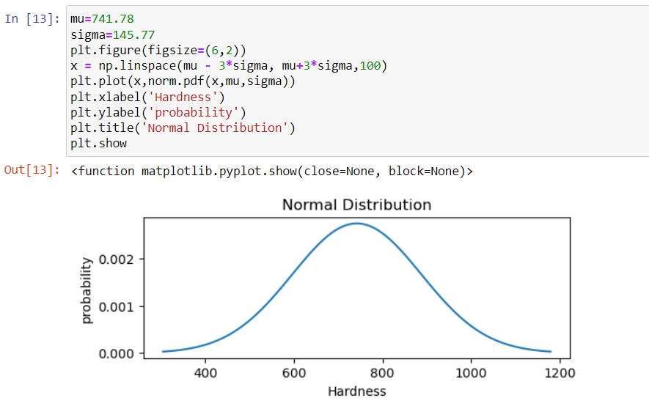
It may be observed from above analysis that there are sufficient outliers in the variable ‘Response’ and the data is normally distributed.

  - Irrespective of your conclusion in 2, we will continue with the testing procedure. What do you conclude regarding whether implant hardness depends on dentists? Clearly state your conclusion. If the null hypothesis is rejected, is it possible to identify which pairs of dentists differ?

Ans: ANOVA Table was created for Response vs Dentist. Tukey’s Honestly Significant Difference (HSD) test was used to compare means of multiple groups whether differences among group means are statistically significant.

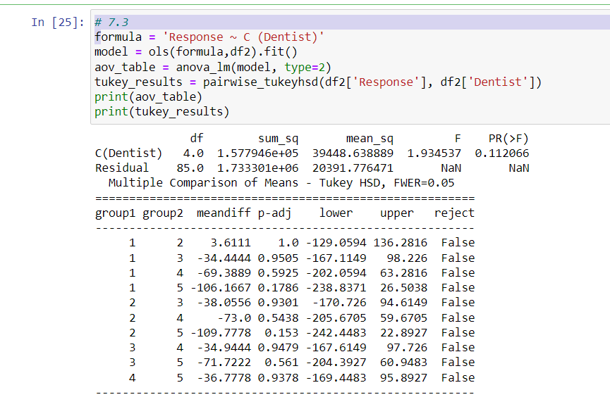

It was observed from the above ANOVA table that p value much is greater than α (0.05), therefore we Fail to reject the Null Hypothesis at 95% significance. It is concluded that there is no significance effect of Dentist for all the combination of groups of Dentists on Implant Hardness. The same is also plotted for both types of alloys and the same is as under:

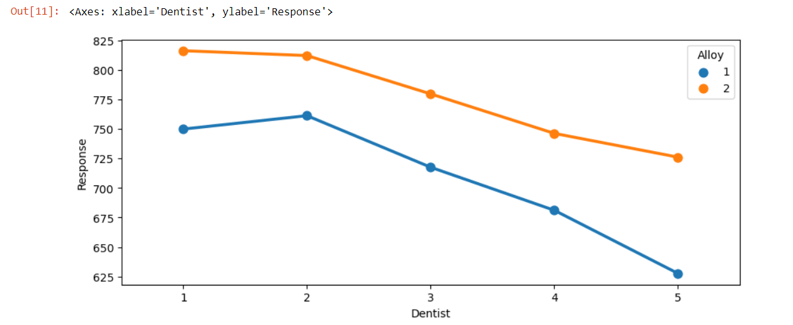

  - Now test whether there is any difference among the methods on the hardness of dental implant, separately for the two types of alloys. What are your conclusions? If the null hypothesis is rejected, is it possible to identify which pairs of methods differ?

Ans: ANOVA Table was created for Response vs Method. Tukey’s Honestly Significant Difference (HSD) test was used to compare means of multiple groups whether differences among group means are statistically significant.

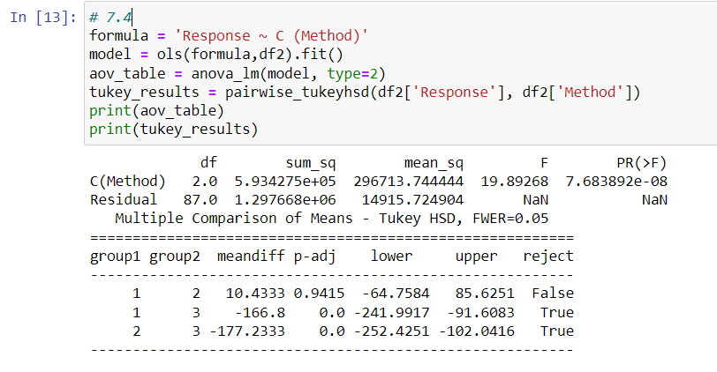

It has been observed from the above ANOVA table that p value is much greater than α (0.05), for pair of Methods 1 & 2, therefore we Fail to reject the Null Hypothesis at 95% significance. It is concluded that there is no significance effect of Method for combination of groups 1& 2 of Methods on Implant Hardness.

It has been further observed from the above ANOVA table that p value is much lower than α (0.05), for pair of Methods 1 & 3 and Methods 2 & 3, therefore we reject the Null Hypothesis at 95% significance. It is concluded that there is significance effect of Method for combination of groups 1& 3 and 2&3 of Methods on Implant Hardness.

The same is also plotted for both types of alloys and the same is as under:

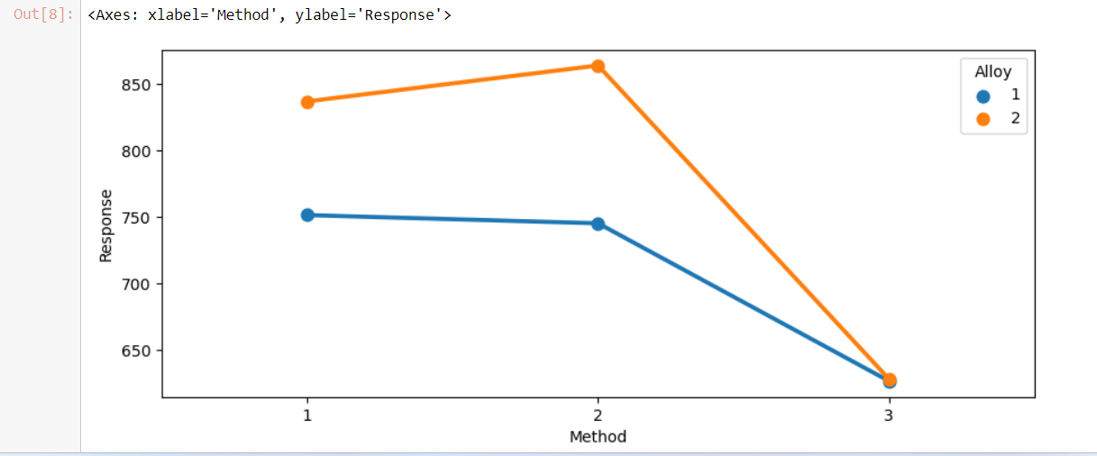

  - Now test whether there is any difference among the temperature levels on the hardness of dental implant, separately for the two types of alloys. What are your conclusions? If the null hypothesis is rejected, is it possible to identify which levels of temperatures differ?

Ans: ANOVA Table was created for Response vs Temperature. Tukey’s Honestly Significant Difference (HSD) test was used to compare means of multiple groups whether differences among group means are statistically significant.

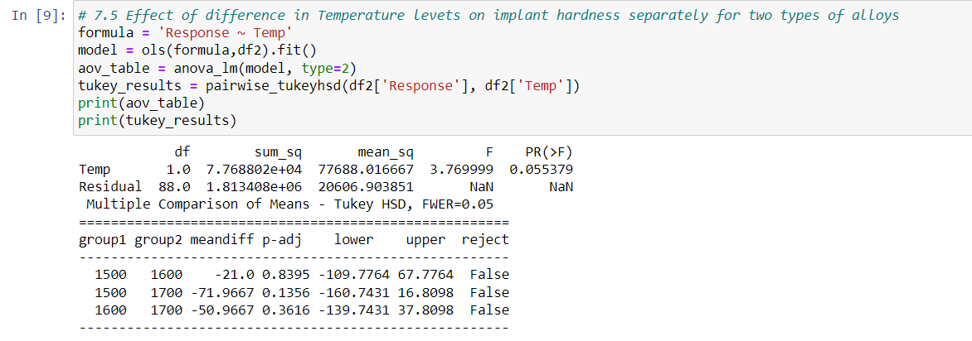

It was observed from the above ANOVA table that p value is greater than α (0.05), therefore we Fail to reject the Null Hypothesis at 95% significance. It is concluded that there is no significance effect of Temperature for all the combination of groups on Implant Hardness. The same is also plotted for both types of alloys and the same is as under:

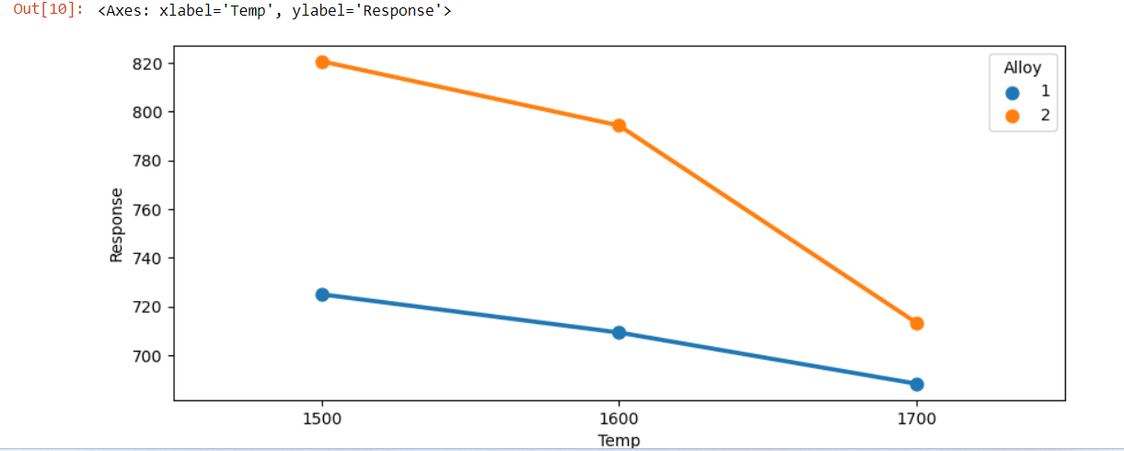

  - Consider the interaction effect of dentist and method and comment on the interaction plot, separately for the two types of alloys?

Ans: ANOVA Table was created for Response vs Dentist: Method (Interaction effect of Dentist and Method).

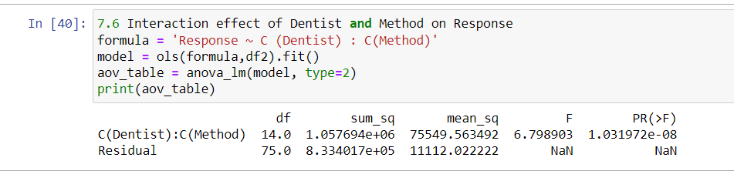

It was observed from the above ANOVA table that p value is much less than α (0.05), therefore we reject the Null Hypothesis at 95% significance. It is concluded that there is significance effect of interaction of Dentist and Method on Implant Hardness. The same is also plotted for both types of alloys and the same is as under:

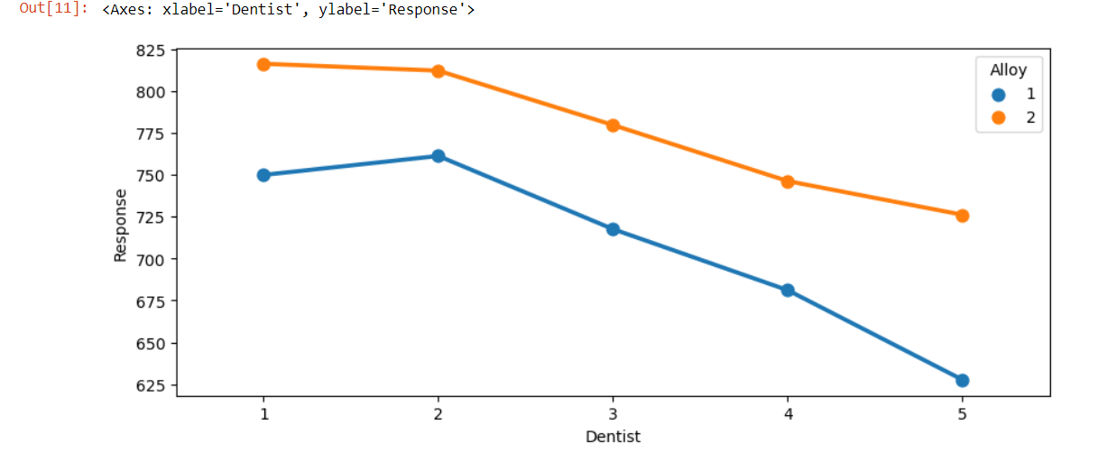

  - Now consider the effect of both factors, dentist, and method, separately on each alloy. What do you conclude? Is it possible to identify which dentists are different, which methods are different, and which interaction levels are different?

Ans: ANOVA Table was created for Response vs Dentist and Method. Tukey’s Honestly Significant Difference (HSD) test was used to compare means of multiple groups whether differences among group means are statistically significant.

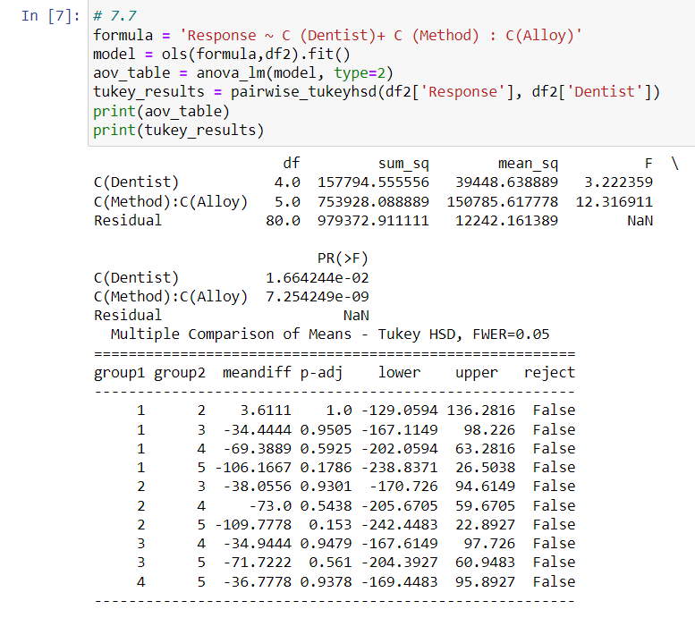
It was observed from the above ANOVA table that p value is much higher than α (0.05), therefore we Fail to reject the Null Hypothesis at 95% significance. It is concluded that there is no significance effect of interaction of Dentist on Implant Hardness for both types of Alloys. It was observed from Tukey HSD Table that for all combination of Dentists, there is no significance effect of interaction of Dentist on Implant Hardness.

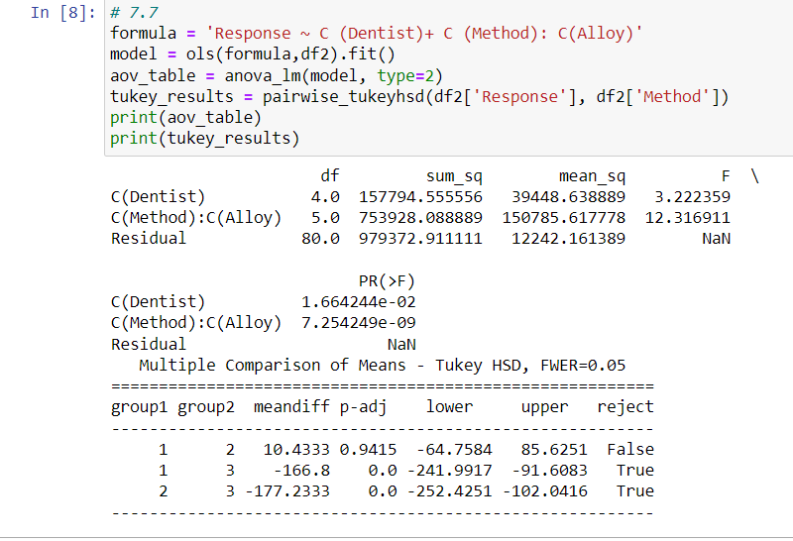
It was observed from the above ANOVA table that p value is much higher than α (0.05) between Group 1 and Group 2, therefore we Fail to reject the Null Hypothesis at 95% significance. It is concluded from Tukey HSD Table that there is no significance effect of Method on Implant Hardness between Methods 1 and 2 for both types of Alloys.

It was further observed from the above ANOVA table that p value is much less than α (0.05) between Group 1 and 3 and Group 2 and 3, therefore we reject the Null Hypothesis at 95% significance. It is concluded from Tukey HSD Table that there is significance effect of Method on Implant Hardness between Methods 1 and 3 and Method 2 and 3 for both types of Alloys.

